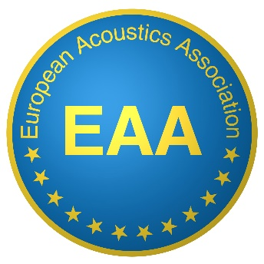
Serving 29 countries and more than 9 000 Members

EAA SUSTAINING MEMBER

Dear Company, Institution, or Organisation,
You are supporting the National activity of your Acoustical Society, and now you can also support its European activities and involvements by becoming a Sustaining Member of the EAA.
The EAA is a non-profit organisation supporting Acoustics in Europe by all possible means:
- 2 journals (Acta Acustica and Acoustics in Practice) and one newsletter (Nuntius Acusticus)
- 3 major Conferences: Forum Acusticum, Euronoise and Euroregio + several workshops
- A multi-lingual European repository (under construction)
- A Web-based University Guide (EAA Schola)
- 8 Technical Committees (more under development)
- A Job Forum (under construction)
- And last but not least a Young Acousticians Network (YAN)
The EAA actions are based on two principles: subsidiarity and solidarity.

As Supporting Member, you can choose one of the following status:
- Silver SM: 1 500 € / year
  - Logo displayed in Fenestra Acustica with a link to the Company website
  - Job announcements inserted in Fenestra Acustica
- Gold SM:3 000 € / year, Same as Silver + in addition
  - Logo displayed in EAA publications and in EAA Conferences
  - 5% discount on advertisement in EAA journals and exhibition in EAA conferences
- Platinum SM: 6 000 € and more / year, Same as gold +, in addition
  - Physical presence during specific actions like specific workshops, prizes, travel

For European Institutions, 25% of your contribution will be deduced from the due of the National Society to the EAA and 75% will be used to support common EAA actions and solidarity.
For non-European Institutions, all your contribution will support EAA actions and solidarity.

Sustaining membership must comply with subsidiarity principle: unless otherwise stated by the National Society, a Supporting Member supporting the EAA should first support and continue supporting the National Society.
EAA SUSTAINING MEMBER
APPLICATION FORM

Institution
- Name:
- Address:
- Country:
- Website:
Contact person:
- Name:
- Phone:
- Email:
Currently supporting (please specify National Society and dates):

Grade of Sustaining Member (please mark your choice):
- Silver: 1 500 € / year
- Gold: 3 000 € / year
- Platinum: 6 000 € and more / year

Declaration:
We are currently supporting our National Society and plan to continue supporting it in parallel with the EAA

Name:

Signature:

Upon approval of your application by the board, an invoice will be sent with payment details

Thank you for your trust in the European Acoustics Association.

Application must be sent by email to the EAA secretariat: secretary@euracoustics.org

